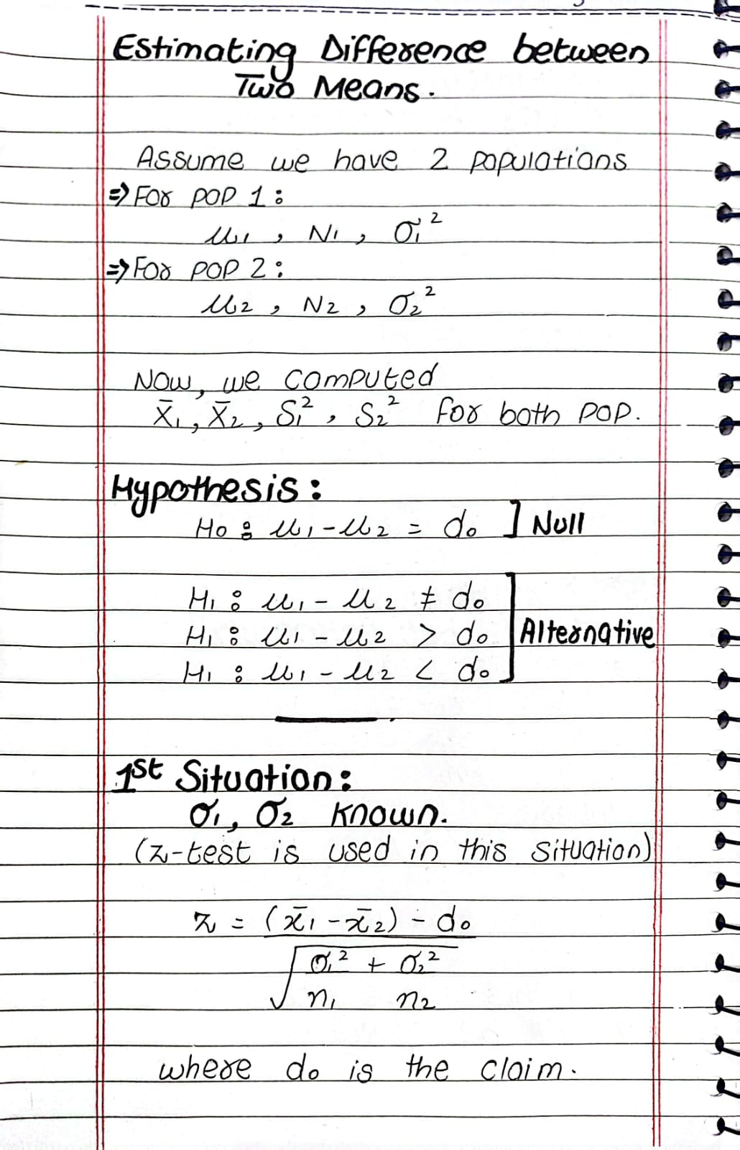

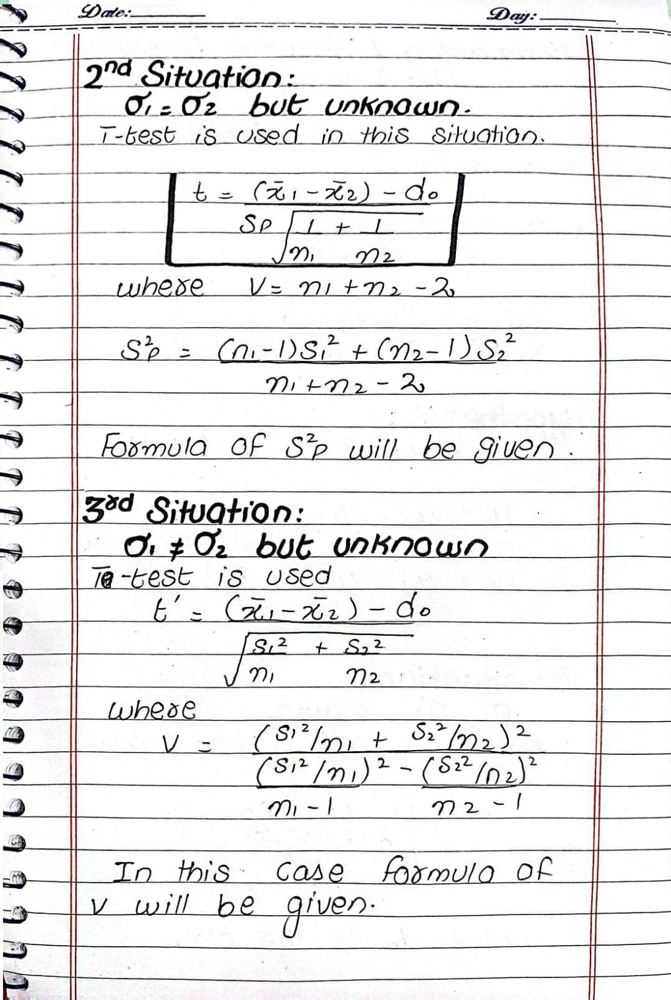c

Question: Two-Sample t-Test (Equal Variances Assumed)
A researcher wants to determine whether the difference in mean scores between two groups exceeds 2 units. The following data is collected: Group 1 Sample size (n1) = 12 Sample mean (xˉ1)= 85 Sample standard deviation (s1)= 4 Group 2 Sample size (n2) = 10 Sample mean (xˉ2)= 81 Sample standard deviation (s2) = 5 Assuming that the populations have equal variances, test at the 0.05 significance level whether the mean difference between the two groups exceeds 2 units.